CS 255 Business Requirements Document Template

System Components and Design

Purpose
The purpose of the DriverPass system is to create a platform that lets students access online practice tests, on road training, and easily book their driving test appointments. DriverPass wants to offer a user friendly platform that covers training, test practice, and appointment scheduling, all with the main aim of helping students become better drivers and improve their chances of passing their driving tests.
This project focuses on:
- Helping students prepare for their driving tests with online practice exams.
- Providing on road training to improve practical driving skills.
- Creating an efficient system for booking driving lessons.
- Enhancing the overall experience of preparing for driving tests to ensure students are well-prepared.
In summary, the purpose of this project is to meet DriverPass's needs and expectations by designing a system that assists students in becoming better and more confident drivers, thereby increasing their likelihood of passing their driving tests.

System Background
DriverPass wants to tackle the problem of poor driver training, which results in many students failing their driving tests.
To address this problem, the system will consist of several of the following major components:
- user authentication for secure login to protect user information.
- appointment scheduling that enables easy booking for lessons while considering instructor availability.
- instructor management, which involves keeping records of instructors, their qualifications, and schedules.
- providing practice questions to aid students in their preparation.
- on road training sessions with instructors aimed at improving practical driving skills.
- progress tracking is included to allow students to monitor their performance and track their progress.
- the system will include a reporting tool to assist in generating reports for instructors and management.

Objectives and Goals
Objectives:
The objectives of the system are to:
- Create a user friendly online platform for students to practice driving exams easily.
- Provide a variety of practice questions, covering different driving scenarios, to help students understand driving better.
- Allow students to see their performance through scores and feedback.
- Let users track their progress, view past results, and measure their improvement.
- Offer practical on road training with professional instructors to enhance the students driving skills.
- Manage driving sessions efficiently, considering both instructor and student availability.
- Generate simple reports on students performance, helping instructors and management.
- Make sure the system safeguards user information and privacy.
Goals:
The goals are achieved if we are able to provide the following functionality:
- Improve security with case sensitive usernames and passwords for user authentication.
- Add an extra layer of security with multi factor authentication for user logins.
- Notify admins immediately to address issues, glitches, or bugs on the website promptly.
- Allow easy changes to user profiles and user removal without needing to change the code for flexibility and easy maintenance.
- Slowly introduce updates based on DriverPass requirements to enhance the platform.
- Provide IT administrators with full access to the system for maintenance and user access management.
- Keep the data safe when it moves between the client and server using cloud based tools, prioritizing data security.
- the system will activate an account lock after four unsuccessful login attempts to safeguard user accounts.
- Offer password recovery through email verification for users who forget their passwords for a user friendly experience.

Requirements

Nonfunctional Requirements

Performance Requirements
- Web based access: the system should be web based, hosted on the cloud for optimal accessibility and speed.
- Regular Updates: regular updates should be possible based on client requirements for ongoing improvements.

Platform Constraints

- The system is intended to run on the Linux platform for compatibility and reliability.
- Cloud infrastructure will handle backend database requirements, enhancing scalability and data management.

Accuracy and Precision
- User identification involves creating case sensitive usernames and passwords during initial website access for data security.
- Multi factor authentication will be implemented to enhance security by requiring multiple forms of verification.
- Immediate admin notifications are crucial for promptly fixing any problems, glitches, or bugs on the website to make sure the user has a smooth experience.

Adaptability
- User profile management: the system can change user profiles and delete users without needing to change the code, making it flexible and easy to manage.
- Responsive updates: updates to the system will happen gradually based on what DriverPass needs. This will reduce disruptions and keep the system stable.
- Administrator access: IT administrators will have full access to the system for maintenance or to revoke access for former employees, ensuring effective system administration.

Security
- User authentication: user login will require a username, password, and multifactor authentication, enhancing the security of user accounts.
- Secure data exchange: the system will securely share data between the client and server using cloud based methods, making sure data stays private and intact.
- Account lockout: If someone enters the wrong login information four times, they won't be able to try again for a while. This helps stop hackers from trying lots of passwords quickly, making things more secure.
- Password recovery: If users forget their passwords, they can recover them through email verification, giving them a convenient way to get back into their accounts.
(Please refer to the next page.)

Functional Requirements
The system shall:

- Validate user credentials during the login process to ensure secure access.
- Let users easily book appointments, making the user experience better.
- Provide online practice tests and courses to facilitate effective driver test preparation.
- Display information about the assigned driving instructor, ensuring transparency and user confidence.
- Have three different driving training options for different student needs.
- Make sure the system works fast and well, enhancing user satisfaction.
- Give specific access based on user roles, keeping data safe.
- Display user progress and finished tasks, helping users track their performance.

User Interface

The user interface helps users book driving appointments and complete online classes and tests. Administrative staff can update the system for efficient management. Users can interact with the interface on different devices like phones, laptops, computers, or any device with an internet connection, ensuring accessibility and convenience for everyone.

Assumptions
- There's no set budget for the system, so I assume that the chosen technologies and resources will fit the budget. This involves using the Linux environment and cloud services for cost effectiveness.
- I assume that the necessary technology resources are easily available, making the development and maintenance of the system straightforward.

Limitations

- The project faces a tight timeline of approximately five months with no specified budget. This requires efficient resource management and effective project oversight.
- Not enough people are a limitation and would need more resources within the five month
time frame. This stresses the importance of using resources efficiently and collaborating well.
- To address these constraints an agile development approach is recommended. This ensures flexibility and adaptability throughout the project's life.

Gantt Chart

LucidChart Gantt Chart version:
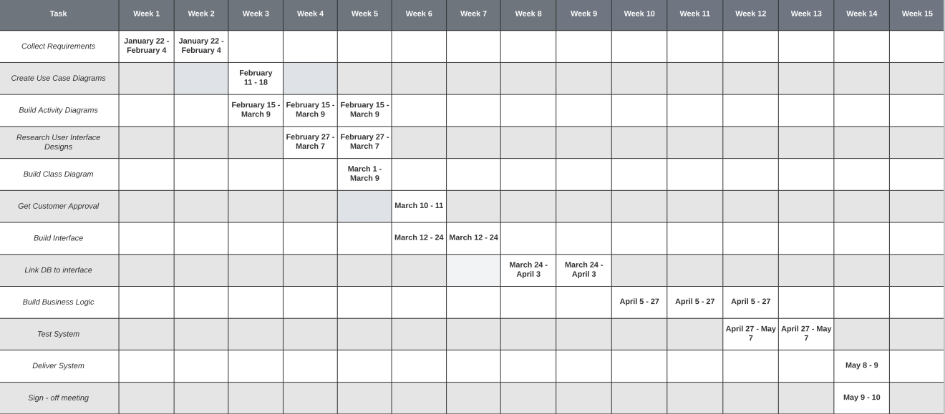
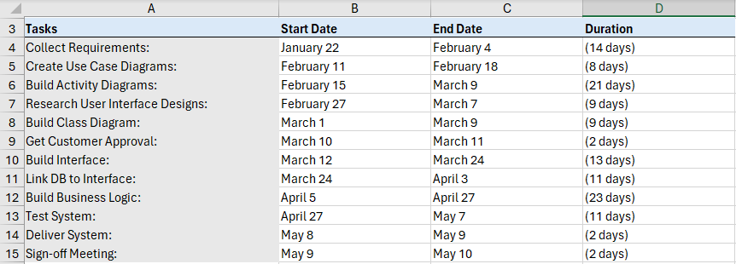
I know the Microsoft Excel version wasn't necessary or part of this assignment but I went ahead and created it anyway. It was the first one I completed before doing it correctly on LucidChart. (I discussed this on the discussion board previously demonstrating my improvement in my LucidChart skills hopefully!)

